Long Term Vision on Management of Acid Soils**
A. K. Sarkar*, A. Kumar and P. Mahapatra
Department of Soil Science & Agricultural Chemistry, Birsa Agricultural University, Ranchi-834006
*Corresponding author (Email: aksarkarranchi@gmail.com)

Introduction
Sustainable agriculture has a significant role in the National economy and food security situation of many developing countries in Asia. Growth of agriculture over the years is therefore, critical to eradicate poverty, hunger, and malnutrition from the region (Fan, 2013). Natural resource constraints, climate change, small land holding and low farm profits are major challenges in this sector. In India, Agriculture is the primary industry, source of livelihood and way of life for more than 70 per cent of the population.
With high population growth, per capita availability of land is decreasing fast. We have about 120 Mha degraded and wastelands in India, which include area affected by salinity, alkalinity, acidity, water or wind erosion, water logging etc. (NAAS, 2010). Most of these areas are inhabited by marginal or landless farmers, poor people with food, nutrition and livelihood insecurity. Rejuvenating such areas through scientific and farmer friendly technologies can help in poverty alleviation and help conserve natural resources.
The present paper analyses the current status of acid soil management and identifies the areas that need attention of scientists, extension workers, planners and administrators in a long term perspective , so as to sustain and improve crop production from such problem soils for higher farm profits.
** Paper published in the SOUVENIR-2017 brought out by the Kolkata Chapter of the ISSS during the 82nd Convention of the Indian Society of Soil Science, New Delhi, held on 11 to 14 Dec.2017.

2.0 Extent of the problem
Acid soils occupy about 18 M ha of land in India (NAAS, 2010).These soils have been categorised under, exclusively acid soils (pH <5.5) with an estimated area of 5.09 M ha, acidic (pH<5.5) and water eroded soils (5.72 M ha) and acid soils under open forest (< 40% canopy) with an area of 7.13 M ha. Such soils are spread in the states of Kerala, Nagaland, Manipur, Tripura, Mizoram, Meghalaya, Assam, Arunachal Pradesh, Chhatisgarh, Jharkhand, West Bengal, Odisha etc. (Table 1). Some of the important districts in these states, which are more affected by soil acidity are given in Table 2.
Table 1. States with large area under Acid Soils in India
State | Area (‘000 ha)
State | TGA (Km²) | Acid soil (<pH 5.5) | Acid soil under Water erosion | Acid soil under open Forest | Total | Area (%)
Nagaland | 16579 | 17 | 45 | 1454 | 1516 | 91
Manipur | 22327 | 115 | 86 | 1396 | 1597 | 72
Tripura | 10486 | 101 | 83 | 525 | 709 | 67
Kerala | 38863 | 1961 | 378 | 87 | 2426 | 62
Mizoram | 21081 | 150 | 0 | 1013 | 1163 | 55
Meghalaya | 22429 | 52 | 175 | 796 | 1023 | 46
Assam | 78438 | 411 | 1319 | 265 | 1995 | 25
Arunachal | 83743 | 300 | 501 | 968 | 1769 | 21
Chhatsgarh | 134805 | 812 | 1383 | 147 | 2342 | 17
Jharkhand | 79714 | 226 | 394 | 115 | 735 | 09
WestBengal | 88752 | 240 | 165 | 13 | 418 | 05
Odisha | 155707 | 107 | 51 | 45 | 203 | 01
Source: NAAS (2010)

Table 2. Districts affected by soil acidity problem in different states of India
State | Districts
Nagaland | Kohima
Manipur | Imphal, Senapati
Tripura | Agartala, Kailashahar, Ambasa
Kerala | Idukki, Kannur, Palakkad, Trissur, Emakulam
Mizoram | Aizwal, Lunglei, Saiha
Meghalaya | Jaintiahills, Westkhasi hills
Assam | KarbiAuglong, Tinsukia, Sibsagar
Arunachal | Anini, Tezu, Deporijo, Along, Ziro
Chhattisgarh | Mahasaamund, Bastar, Datewada, Durg
Jharkhand | Ranchi, WestSinghbhum, Dumka, Deoghar, EastSinghbhum
West Bengal | North Dinajpur, Jalpaiguri, Purulia, Bankura, Malda,
Odisha | Gajapati, Angul, Ganjam, Dhenkanal
Source: NAAS (2010)

Acid soils are classified as laterites and lateritic, mixed red and yellow soils, ferruginous red soils, brown forest podzolic soils, coastal alluvial soils, peat soils, degraded saline and acid saline soils (Murthy et al., 1976, Maji et al., 2012). Recently, Sahoo and Sarkar (2013) have presented a detailed account of the genesis and classification of Indian acid soils.

3.0 Reasons for Soil acidity development
Acid soils are formed mainly from acidic parent materials and leaching of bases caused by high rainfall. Acid granite rocks as parent material, for example, in the process of soil formation, render the soil acidic. Continuous use of acid forming fertilisers, such as ammonium sulphate or urea in soils create soil acidity. Movement of excess water through soil rapidly in sloppy terrain in high rainfall areas is an important factor in acid soil development. The regions with annual rainfall of 1350 mm have acid soils with pH value 5.0 or less. Microorganisms are responsible for the decomposition of organic residues. Organic acids, thus formed during the process are neutralised by basic ions, such as Ca, Mg, etc. If base saturation is low, acids generated are not neutralised. In coastal and marshy areas, dense vegetation is accompanied by high rainfall and water logging. Under such situations, organic materials do not get enough oxygen to decompose completely. This gives rise to soil acidity. Topography also influences soil formation by moderating hydrological conditions. Oxidation of S-containing compounds present in soils, also leads to acidity development, as in case of acid sulphate soils.

4.0 Health of acid soils and Crop performance
The indicators of health of acid soils in order of importance are soil pH, exchangeable Al³⁺, available P, water holding capacity, CEC, exchangeable Ca²⁺, soil texture and soil organic matter and microbial population. In hilly terrain, extent of soil loss and nutrient loss are important (Sarkar, 2013).
pH is the master variable controlling the availability of nutrients in acid soils (Malavolta,2006). Availability of nutrients is highest in soil pH range of 5.8 and 7.0 (Fig.1). As soils become more acidic, solubility of Fe, Cu, Mn, Zn, Co and Ni increases. Al toxicity is important, when soil pH is below 5.5. P, K, Ca, Mg are low in soil pH is below 5.5. Mo, B and S are low at pH below 5.8. At low pH (<5.0), Al containing materials in soil (clay and sesquioxides) start dissolving and trivalent Aluminium concentration increases in soil solution and also on the exchange complex. The amount of dissolved aluminium is about 1000 times greater at pH 4.5 than at pH 5.5. This adversely affects root activity and impacts negatively the water and nutrient absorption by growing plants.
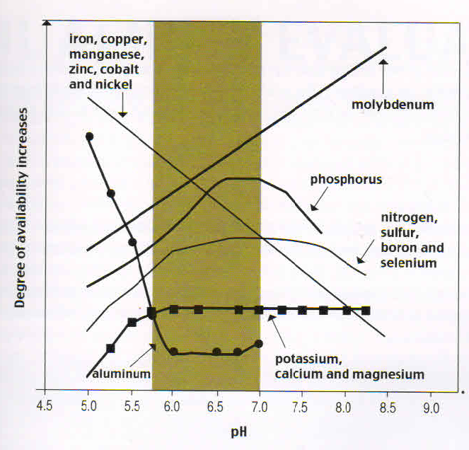
Fig.1. Typical effect of change in soil pH on the availability of plant nutrients
Source: Malavolta, 2006

Most acid soils are deficient in a number of plant nutrients, both macro and micro indicating poor soil health (Sarkar and Singh, 2003; Sarkar etal. 2007). Soil analysis from acid soil regions indicate low Ca and Mg status with widespread deficiency of S (Tables 3, 4). A recent study (Table 5) on the S and micronutrient status of acid soils of eastern region, indicate widespread deficiency of S, B, and Zn (Anon.2017), which is highest in soils of Jharkhand, probably because of lighter texture and poor organic matter contents. Information regarding availability of Mo in acid soils of India is quite meagre. Mo deficiencies to the extent of 55 and 59% in acidic soils of Jharkhand and Odisha have earlier been reported. Reduced base saturation causes nutritional problems, especially in animals, such as milk fever and grass tetany. Nodulation in legumes and symbiotic nitrogen fixation are adversely affected by Mo, Ca, Mg and P deficiency in acid soils.
Table 3. Exchangeable calcium and magnesium in acid soils of some states
States | No. of samples | pH | Exchangeable Ca²⁺  cmol(p⁺)kg⁻¹ |  | Exchangeable Mg²⁺  cmol(p⁺)kg⁻¹
States | No. of samples | pH | Range | Mean | Range | Mean
Assam | 50 | 4.0-5.1 | 1.82-2.97 | 2.32 | 1.48-2.00 | 1.75
Himachal Pradesh | 100 | 5.0-5.6 | 1.08-4.70 | 3.10 | 1.0-2.8 | 1.80
Jharkhand | 125 | 4.4-6.5 | 2.28-12.15 | 5.57 | 0.58-2.91 | 1.59
Meghalaya | 63 | 4.3-5.6 | 0.20-5.80 | 1.10 | 0.60-1.50 | 0.94
Maharastra | 92 | 4.5-5.5 | 2.70-5.05 | 3.20 | 1.10-3.00 | 2.29
Source: Sarkar and Singh (2003)

Table 4. Available S content and magnitude of S deficiency in acidic soils of some states
States | Soil  Groups* | Available S (mg kg⁻¹) |  | % sample  S-deficient
States | Soil  Groups* | Range | Mean | % sample  S-deficient
Andhra Pradesh | Alfisol | 3.1-140.4 | 15.5 | 47.6
Assam | Entisol |  | - | 20.0
Himachal Pradesh | Oxisol | 0.5-25.0 | 7.4 | 174.0
Jharkhand | Alfisol/ Ultisol | 0.33-94.7 | 10.9 | 50.5
Karnataka | Alfisol | 4.0-37.7 | 17.5 | 9.8
Kerala | Alfisol | Tr-112.2 | 28.5 | 23.9
Maharashtra | Alfisol | 2.6-8.9 | 4.0 | 100.0
Odisha | Alfisol | Tr-64.2 | 16.4 | 21.0
Odisha | Alfisol | Tr-28.1 | 13.1 | 43.0
Odisha | Entisol | Tr-25.7 | 8.0 | 75.0
Tamil Nadu | Alfisol | 9.5-120.0 | 31.6 | 19.6
Source: Sarkar and Singh (2003)* These mostly refer to red and lateritic soils.

Table 5. Secondary and micronutrients deficiency status (%) in eastern Zone of India
State | No. of Soil samples | pH range | S | Zn | Fe | Cu | Mn | B
Jharkhand | 1539 | 3.78-6.56 | 55.0 | 17.6 | 0.17 | 0.74 | 0.23 | 60.0
Assam | 7208 | 4.04-6.06 | 22.00 | 26.67 | 0.00 | 2.80 | 0.00 | 32.7
Manipur | 1504 | 5.4-6.8 | 8.00 | 11.90 | 2.27 | 2.44 | 2.05 | 37.2
Odisha | 5810 | 3.6-6.9 | 30.41 | 29.52 | 8.41 | 8.32 | 2.73 | 48.9
West Bengal | 3870 | 4.78-6.09 | 55.2 | 14.75 | 0.00 | 1.83 | 0.91 | 37.1
Source: Anon.(2017)
Acid soils often have low cation exchange capacity (Kaolinite dominated soils) and high phosphate fixation capacity leading to poor water and nutrient retention and low supply of available P to crops. Population of bacteria and actinomycetes is low in most acid soils; while fungal population is high. This imbalance adversely affects the biological transformation of plant nutrients in soils.
Crops perform differently in acid soils depending on their preference to grow well in a certain range of soil pH. In general, yields of pulses, oilseeds, maize and wheat are poor in low pH soils (Mandal et al., 1975). On the other hand, rice, minor millets, potato, mesta, niger, mustard and plantation crops, such as tea, coffee perform well under acidic soil environments. Crops like soybean, pigeon pea, potato, cotton and vegetables respond to liming, indicating their sensitivity to soil acidity.

5.0 Crops and Cropping systems
In large parts of eastern and north-eastern India with acid soils, farmers grow rice in uplands and medium lands. This is not profitable as the yield levels are low and farmers leave their land fallow after rice harvest due to non-availability of irrigation or due to problem of stray cattle grazing. This has resulted in farmer’s distress and acute food shortages. The existing cropping systems in rain fed uplands are Rice/ Maize-fallow, Rice/ Gundli-fallow, fallow-niger/ horsegram or Pigeon pea/ black gram-fallow. Rainwater harvesting and re-charge of groundwater is a priority area for ensuring irrigation for dry season crops. Existing water bodies need renovation for efficient water harvesting (ponds, ditches, and wells) and its utilization for providing life saving irrigation to crops. Thus, crop diversification through intercropping in uplands and sequence cropping in medium lands is essential. Some such diversification are: Pigeon pea + groundnut or black gram (1:2), Pigeon pea + rice (1:3), Maize + pigeon pea or black gram (1:2), Rice-pea/ chickpea/ gram etc. Soils need lime application along with nutrients, such as N, P, B, S, K, as per soil tests. Soil and water conservation measures must be adopted for growing intercrop or sequence crop to boost productivity in such areas (Pattanayak and Sarkar, 2016).

6.0 Amelioration of Soil Acidity
Pioneering work by Professor S.C. Mandal and his co-workers paved the way for systematic research on acid soil management. These workers identified liming as the most important input for amelioration of soil acidity (Mandal et al., 1966; Mandal et al., 1975; Mathur et al., 1985). The investigations were focussed on (i) response of crops to liming (ii) lime requirement of acid soils (iii) quality of liming materials (iv) fineness of liming materials (v) frequency of liming (vi) methods of lime application (vii) crop rotation in relation to liming etc. It was found that all the liming materials when added on equivalent lime basis, were more or less equally effective in increasing the yield of crops in acid soils. The minimum fineness of the liming material to be effective should be such that it passes through 10 mesh sieve, but in the case of basic slag, which pass through 30 or 40 mesh sieve are recommended for application as a soil amendment. Considering major soil related constraints in acid soils of India, studies were undertaken on their correction by several workers. These have been well documented (Panda et al., 1991, 1996; Sarkar et al. 2007; Jena, 2008; Pattanayak, 2000, 2014).
Subsequently, attempts were made to reduce the dose of lime to one fourth to one half of the lime requirement and apply in split doses. Lime provides Ca , which is in short supply in acidic soils due to removal by growing crops and leaching due to high rainfall. Mathur et al. (1985) reported that by application of 3-4 q ha⁻¹ of lime in furrows below the seed at sowing, could increase the yield of groundnut, soybean, gram and barley by 20 to 36 per cent. Liming at this level increased the pH as well as calcium saturation of soils by 37 to 50 per cent (Table 6 and 7) in kaolinite rich soils. Mathur et al. (1989) compared lime application @ 1/10, 1/15 and 1/20th of lime requirement (LR) applied in Rhizosphere at sowing for six years with LR dose applied as broadcast only once in the beginning. The mean yield of urd bean, soybean, groundnut, lentil and other crops grown with 1/20 LR dose was at par with 1 LR dose. After six years, exchangeable Calcium was found to be the highest in soils receiving 1/10 LR dose of lime and was more profitable than LR dose (Table 8). The uptake of phosphorus by crops was greatly enhanced by liming. The return per rupee investment not only increased with time at all split doses of lime, but also the gap between full dose and lower doses of lime narrowed down, showing thereby higher profitability at lower doses in most crop rotations.
Table 6. pH, exchangeable Ca saturation of soils as affected by lime application
Lime | Groundnut |  |  | Soybean |  |  | Gram
(Q/ha) | pH | Exch.  Ca** | Ca saturation% | pH | Exch.Ca | Ca saturation% | pH | Exch.Ca | Ca saturation%
Control | 5.2 | 3.3 | 38.4 | 5.1 | 3.2 | 37.2 | 5.5 | 3.2 | 37.2
As per LR* | 6.9 | 5.3 | 61.6 | 6.7 | 3.5 | 40.7 | 6.9 | 4.7 | 54.6
2 | 5.6 | 3.4 | 39.5 | 5.4 | 3.4 | 39.5 | 5.7 | 3.4 | 59.5
3 | 5.6 | 3.5 | 40.7 | 5.6 | 3.7 | 43.0 | 5.8 | 3.6 | 41.9
4 | 5.7 | 3.6 | 41.9 | 6.0 | 4.1 | 47.7 | 6.0 | 3.9 | 45.3
5 | 6.0 | 4.5 | 50.0 | 6.1 | 4.3 | 50.0 | 5.2 | 4.2 | 48.8
*Lime requirement
**Cmol(P+)kg⁻¹

Table 7. Grain yield(q ha⁻¹) of Crops with lime application in Acid soils
Lime(q/ha) | Groundnut |  | Soybean |  | Gram |  | Barley
Lime(q/ha) | Yield | % increase | Yield | % increase | Yield | % increase | Yield | % increase
Control | 17.5 |  | 20.3 |  | 13.1 |  | 24.3
As per LR* | 22.7 | 29.9 | 28.1 | 38.4 | 18.4 | 40.1 | 35.6 | 46.2
2(furrow) | 20.8 | 19.0 | 24.8 | 22.2 | 16.0 | 22.1 | 30.1 | 23.6
3(furrow) | 20.8 | 19.0 | 27.3 | 34.6 | 16.4 | 25.4 | 32.0 | 31.6
4 (furrow) | 20.7 | 18.5 | 26.3 | 29.3 | 17.2 | 31.5 | 33.8 | 38.8
5 (furrow) | 21.3 | 21.9 | 26.1 | 28.6 | 16.7 | 27.2 | 33.7 | 38.6
C.D. at 5% | 1.2 |  | 1.4 |  | 1.3 |  | 1.4
*L.R. Lime requirement of soils growing groundnut, soybean, gram and barley were 46.5, 55.0, 28.5, and 28.5 q ha⁻¹, respectively.

Table 8. Grain yield (q/ha) of crops due to liming in acidic soils of Jharkhand
Treatments | Crops
 | Moong | Groundnut | Urad | Soybean | Lentil | Pea | Gram
No Lime | 2.8 | 12.0 | 5.8 | 13.3 | 11.4 | 11.3 | 2.2
1 LR (Broadcast) | 6.1 | 16.7 | 12.1 | 22.0 | 17.7 | 17.6 | 5.1
1/10 LR (Furrow) | 6.0 | 17.2 | 11.5 | 22.0 | 17.6 | 16.6 | 6.1
1/15 LR (Furrow) | 5.8 | 16.0 | 11.3 | 21.7 | 17.1 | 16.2 | 5.9
1/20 LR (Furrow) | 5.3 | 15.2 | 11.1 | 20.4 | 15.8 | 15.6 | 5.7
CD (P=0.05) | 0.03 | 1.6 | 1.8 | 19.8 | 1.8 | 1.7 | 1.8

Under the ICAR Network project on Acid Soils, altogether 871 farmer participatory field experiments were designed and conducted in different acid soil regions of the country for a period of five years (2000 -2005). The treatments used in these experiments, comprised of the following: Farmer practice (FP), Farmer practice + Lime, 100% NPK and 100% NPK + Lime (2000-2003). In another set of farmer’s field experiments (2004-2005), the treatments were: Farmers practice, 100% NPK, 50% NPK + Lime and 50% NPK + Lime + FYM.
Crops were grown without lime and with lime (locally available) + fertilisers recommended for the crops. Lime application @ 2-4 q ha⁻¹ was done in furrows of direct seeded crops along with fertilisers at the time of sowing. Results reveal that, lime alone increased the yield of crops from 13.83 to 49.44 per cent with a mean value of 27.87 per cent (Table 9). Response of lime was good in groundnut + pigeon pea system in Odisha (49.44%) and Jharkhand (29.96%). Marked yield enhancement in case of liming over farmers practice was observed for maize in Palampur (15.98%), and Meghalaya (29.96%), for rapeseed (17.81%) and summer green gram (13.88%) in Assam, for wheat (16.22%) in Palampur and groundnut (17.61%) in Maharashtra. The recommended dose of fertiliser application with lime increased the crop yields by about 97% over farmers practice. Liming and fertilization proved to be economical to different crops in acid soil regions. The benefit: cost ratio increased with liming alone (farmers practice + lime), addition of fertilizers (100% NPK) and conjunctive use of fertilisers and lime (100% NPK + lime). The benefit: cost ratio varied from 1.4 to 4.3 with conjunctive use of lime and fertilisers (Table10). Further, application of FYM with 50% recommended NPK + lime increased the yield of crops from 6 to 82 per cent over 100% NPK application. Results show that conjunctive use of lime and FYM even with 50% NPK application was superior because of higher crop yields with improved soil health (Table 11). The technology package developed based on these studies ( Anon.2006;Sharma and Sarkar,2006) for managing soil acidity is presented in Table 12.
Table 9. Effect of liming and fertilization on crop yields (q ha⁻¹) in India
State | crop | FP | FP+ lime | Rec. NPK | Rec. NPK + lime
Assam | Rapeseed | 7. 3 | 8. 6 (18) | 10. 5 (43. 8)* | 12. 9(76. 7)
Assam | Green gram | 10. 1 | 11. 5 (14) | 12. 3 (21. 6) | 15. 1(49. 0)
Himachal Pradesh | Maize | 23. 5 | 27. 4 (17) | 34. 0 (44. 7) | 37. 5(59. 6)
Himachal Pradesh | Wheat | 17. 4 | 20. 2 (16) | 27. 9(60. 3) | 31. 7(82. 2)
Jharkhand | Maize | 17. 1 | 21. 5 (26) | 25. 1(46. 9) | 29. 6(73. 3)
Jharkhand | Pigeon pea | 7. 4 | 10. 0 (34) | 12. 0(61. 3) | 15. 2(105. 3)
Kerala | Black gram | 3. 5 | 4. 4 (26) | 4. 0 (14. 8) | 5. 6(58. 3)
Maharashtra | Groundnut | 14. 2 | 16. 7 (18) | 19. 9(40. 1) | 24. 3(71. 2)
Meghalaya | Maize | 10. 6 | 13. 8 (30) | 21. 1(99. 1) | 30. 6(189. 2)
Odisha | Groundnut | 8. 6 | 12. 5 (45) | 14. 3(66. 3) | 17. 9(108. 1)
Odisha | Pigeon pea | 10. 5 | 15. 1 (44) | 16. 4(56. 2) | 20. 2(92. 4)
West Bengal | Mustard | 4. 8 | 6. 5 (35) | 7. 0(45. 8) | 9. 1(89. 6)
West Bengal | Wheat | 10. 2 | 15. 5 (52) | 15. 0(47. 1) | 19.0(86.3)
*Figures in ( ) indicate % increase over FP plots

Table 10. Benefit: Cost ratio of liming and fertilization of Crops in acid soils
Acid Soil Region / State | Crop | Farmer’s practice (FP) | FP + Lime | 100 % NPK | 100% NPK + Lime
Assam | Rape seed | 2.30 | 2.72 | 2.77 | 3.40
 | Summer green gram | 2.36 | 2.69 | 2.71 | 3.19
Himachal | Maize | 1.15 | 0.97 | 1.99 | 1.73
 | Wheat | 0.73 | 1.02 | 1.46 | 1.79
Jharkhand | Maize + Pigeonpea (Maize equivalent yield) | 1.52 | 1.85 | 1.97 | 2.37
 | Pea (pod) | 1.70 | 1.87 | 2.39 | 2.78
Kerala | Blackgram | 1.47 | 1.63 | 1.36 | 1.84
Maharastra | Groundnut | 1.25 | 1.40 | 1.61 | 1.76
Meghalaya | Maize | 1.00 | 1.27 | 3.58 | 3.45
 | Mustard | 1.00 | 0.63 | 1.32 | 2.35
Odisha | Groundnut | 0.76 | 1.03 | 1.17 | 1.37
Odisha | Pigeonpea | 1.13 | 1.48 | 1.59 | 1.80
Odisha | Groundnut + Pigeonpea | 1.64 | 2.27 | 2.56 | 2.93
West Bengal | Mustard | 1.70 | 3.20 | 3.00 | 4.30
West Bengal | Wheat | 1.40 | 2.70 | 2.20 | 3.00
Mean of all crops |  | 1.41 | 1.78 | 2.11 | 2.54

Table 11. Effect of lime, fertilizer and FYM application on crop yield (q ha⁻¹) in acid soils
States | Crop | 100 % NPK | 50 % NPK + Lime | 50% NPK + Lime + FYM
Assam | Rape seed | 9.7 | 10.1 (4.1) | 11.9 (22.68)
Assam | Summer green gram | 4.4 | 5.2 (18.2) | 6.8 (54.5)
Himachal | Maize | 34.0 | 33.1 (-2.7) | 36.1 (6.2)
Himachal | Wheat | 27.9 | 23.7 (-15.0) | 29.8 (6.8)
Jharkhand | Maize + Pigeon pea (Maize equivalent yield | 69.0 | 65.0 (-5.8) | 82.5 (19.6)
Jharkhand | Pea (pod) | 38.4 | 50.8 (32.3) | 69.7 (81.5)
Kerala | Cow pea | 8.6 | 10.6 (23.3) | 11.3 (31.4)
Kerala | Black gram | 6.4 | 8.1 (26.6) | 9.2 (43.7)
Meghalaya | Maize | 30.5 | 30.3 (-0.7) | 36.4 (19.3)
Meghalaya | Groundnut | 14.2 | 21.3 (50.0) | 25.4 (78.9)
Odisha | Groundnut | 22.5 | 23.6 (4.9) | 26.6 (18.2)
Odisha | Pigeon pea | 12.0 | 12.2 (1.7) | 14.6 (21.7)
West Bengal | Mustard | 8.2 | 8.4 (2.4) | 11.2 (36.6)
West Bengal | Wheat | 16.7 | 17.1 (2.4) | 22.1 (32.3)
All state | Average of all crops | 27.1 | 22.8 (-15.9) | 28.1 (3.7)
( ) % yield increase/ decrease over 100 % NPK.

Table 12. Technology of Lime application in Acid Soils
- Target area: rain fed/irrigated uplands and medium lands (pH <5.5)
- Crops: Pigeon pea, soybean, groundnut, lentil, pea, cotton, maize, wheat, linseed, mustard etc.
- Rate: 200 to 500 kg lime/ha in furrows (10% of LR for monocots & 20% of LR for dicots), mixed with compost.
- Source : Locally available lime source, cheap with good neutralizing value
- Method: to be applied in furrows along with recommended fertiliser doses manually or through seed cum fertiliser drills at sowing of each crop.

Results from the field experiments with application of paper mill sludge @ 0.2LR applied in furrows below the seed at sowing (Pattanayak et al., 2008; Jena, 2013a; Pattanayak, 2014) reveal 17 to 36 per cent yield increase in groundnut over farmer’s practice (FP) in red soils of Mayurbhanja, Ganjam and Nayagarh (Table 13). Yield of green gram increased by 5-21 per cent over FP in laterites of Khurda and Dhenkanal. Pattanayak (2008) advocated the con-joint use of bio-fertilisers with inorganic fertilisers and lime in acid soils for improved efficiency of utilization of plant nutrients. Results (Table 14, 15) reveal that integration of bio-fertilisers (Rhizobium, PSB and Azotobacter + Azospirillum + PSM( in the ratio of 1:1:1) and application with soil test based nutrient use, resulted in increased production of cereals (7-27%), pulses (10-21%), oilseeds (12-21%) and vegetables (10-17%) in acid soils with pH ranging from 4.56 to 5.47. This with paper mill sludge @ 0.1 LR for cereals and 0.2 LR for pulses, vegetables and oilseeds increased the productivity of cereals (18-35%), pulses (20-40%), oilseeds (21-44%) and vegetables (21-37%). Liming inactivated the excess Aluminium in low pH soils and created a favourable environment for plant roots and microbes to grow.
Slide 13. Response of different crops to lime in acid soils of Odisha
Crop | District | pH range | No. of  trials | FP* | FP+ lime* | Response  (%) | B:C ratio
Groundnut | Dhenkanal | 4. 0-6. 3 | 9 | 0. 84 | 1. 14 | 36 | 2. 34
Groundnut | Mayurbhanja | 4. 8-5. 2 | 11 | 1. 00 | 1. 76 | 17 | 1. 75
Groundnut | Nayagarh | 5. 5-5. 7 | 10 | 1. 07 | 1. 27 | 19 | 1. 20
Groundnut | Ganjam | 5. 6-6. 1 | 7 | 1. 91 | 2. 39 | 25 | 4. 32
Green gram | Khurda | 5. 5-6. 5 | 12 | 0. 81 | 0. 89 | 10 | 1. 50
Green gram | Dhenkanal | 3. 8-6. 0 | 10 | 0. 82 | 0. 99 | 21 | 1. 60
Cabbage | Kandhamal | 5. 9-6. 6 | 5 | 11. 17 | 13. 00 | 16 | 5. 40
Cabbage | Koraput | 5. 8-7. 3 | 7 | 22. 40 | 25. 69 | 15 | --
Cauliflower | Kandhamal | 6. 0-6. 1 | 5 | 9. 95 | 12. 10 | 22 | 4. 05

Table 14. Response of crops to lime and biofertiliser application in acid soils of Odisha.
Crops | Economic yield (kg ha⁻¹)
Crops | STD** | STD + BF | STD + L + BF | LSD (P=0.05)
Cereals
Maize | 5421 | 5788(7) | 6364(18) | 198
Finger millet | 2220 | 2820(27) | 3010(35)* | 220
Pulses
Green gram | 630 | 760(21) | 880(40) | 110
Black gram | 703 | 835(19) | 920(31)
Arhar | 1580 | 1740(10) | 1890(20) | 140
Oilseeds
Groundnut | 1180 | 1430(21) | 1700(44) | 90
Sunflower | 2140 | 2390(12) | 2590(21) | 150
Vegetables
Garden pea | 9200 | 10800(17) | 12600(37) | 1130
Spine gourd | 3470 | 3940(14) | 4380(26) | 210
Cabbage | 42500 | 46600(10) | 51700(22) | 3900
Pointed gourd | 8230 | 2390(14) | 10890(32) | 480
Knol khol | 26330 | 29150(11) | 31730(21) | 1390
*Data in the parenthesis indicate per cent increase over STD
** Soil test based dose of NPK

Table 15. Influence of long term (7 years) lime application as INM component for crops grown in acid upland soils** (Inceptisols Bhubaneswar)
INM practices | Productivity of crops grown in sequence (t ha⁻¹)
INM practices | Green gram | Maize | Cabbage | Cowpea | Ragi | Cowpea | Maize | Cauliflower
STD | 0.54 | 5.47 | 18.6 | 0.26 | 2.16 | 0.25 | 4.00 | 2.0
STD + Organics | 0.80 | 6.30 | 43.5 | 0.63 | 2.40 | 0.61 | 6.10 | 10.2
STD + Orga. + BFs | 0.89 | 7.00 | 48.1 | 0.72 | 2.46 | 0.70 | 6.41 | 13.4
STD+Orga.+  Lime + BFs | 0.96(8)8 | 7.60(9) | 52.6(10) | 0.80(11) | 2.88(12) | 0.79(13) | 6.95(8.4) | 16.8(25)
LSD (P =0.05) | 0.03 | 0.30 | 1.8 | 0.03 | 0.12 | 0.028 | 0.14 | 0.18
*Data in the parenthesis indicate per cent increase due to lime application
** Initial soil pH-5.1

Long term field studies serve as an educational tool to demonstrate the beneficial or harmful effect over a period of time, on the use of critical inputs, such as organic manure, lime, fertilisers etc. either used singly or in combination on crops. The effect varies with the measures adopted to bring about changes in the soil health, crop performance in terms of yield and quality of produce. One such study, is the Permanent manorial trial of Ranchi, which was initiated in 1956 with Maize-wheat sequence in an acidic red loam soil signifying typical upland situation with soil pH 5.5. Decade wise yield of maize and wheat show that in the first four decades (1956-1995), nutrient application (N, NP, NPK) resulted in a steady decline in crop yields (Table 16). This process was reversed in limed plots receiving NPK application. Over the last five decades, in the absence of lime (as an amendment for the acid soil) NPK application was not effective in increasing crop yields. Sustainable yield index (SYI) calculated from the yield data as affected by different NPK and lime treatments reveal the progressive management practice capable of producing high yields over years. SYI of 42.78 in case of maize and 35.96 in wheat over the last five decades (Table 17) indicates that in acid soils for sustaining high yields, balanced chemical fertilization preceded by liming is essential (Sarkar, 2013).
Table 16. Grain yield (kg ha⁻¹) of maize and wheat grown in rotation from 1956 to 2005 (50 years) as affected by fertilizers and lime application.
Treatments | Year |  |  |  |  | Mean value
Treatments | 1956 to 1965 | 1966 to 1975 | 1976 to 1985 | 1986 to 1995 | 1996 to 2005 | Mean value
Maize (Kharif)
Unfertilized | 1638 | 914 | 525 | 523 | 492 | 716
N | 1638 | 1029 | 27 | 30 | 078 | 421
NP | 2174 | 2436 | 296 | 95 | 724 | 1033
NPK | 2637 | 2830 | 626 | 145 | 952 | 1309
Lime + NPK | 2402 | 3038 | 3970 | 4806 | 4506 | 3893
Wheat (Rabi)
Unfertilized | 519 | 609 | 626 | 976 | 802 | 721
N | 559 | 291 | NIL | 17 | 124 | 150
NP | 1608 | 2174 | 1007 | 435 | 1607 | 1380
NPK | 1738 | 2277 | 1707 | 916 | 1708 | 1695
Lime + NPK | 1426 | 2728 | 3169 | 4984 | 3854 | 3402

Table 17. Sustainable Yield Index of maize and wheat as affected by continuous cropping and nutrient use

Treatments | Maize | Wheat
Unfertilized | 2.99 | 8.43
N | -4.69 | -1.02
NP | -1.84 | 8.15
NPK | -0.05 | 14.69
Lime + NPK | 42.78 | 35.96

Another long term study with Soybean-wheat sequence in Ranchi, initiated by ICAR in 1972, reveal that application of FYM or lime along with NPK is a sustainable practice. Among the soil properties affected is the pH, which increased from 5.3 to 6.2 in a span of 40 years due to lime application, while that in plots receiving FYM, pH decreased to 4.9 from the initial value of 5.3. This shows that in acid soils with low organic carbon, one has to add both FYM and lime for better results. Crop yields followed the order NPK+FYM>NPK+lime>NPK (Table 18). Nutrient uptake pattern was also in the same order as in case of yield. Apparent nutrient recovery of N, P, or K was high in lime or FYM amended soil receiving NPK application. The partial factor productivity calculated based on the increase in grain yield per unit input applied are presented in Table 19. Results reveal that both lime and FYM had considerable residual effect, which enhanced the yield of wheat. NPK + FYM was comparable to NPK + lime as factors influencing crop yields over the years. The active fraction of soil organic carbon (SMBC, SMBN) changed significantly with different inputs. N and NP treatments as compared to balanced NPK application resulted in a decrease in active carbon content of soil. This indicates that long term cultivation of crops led to depletion of soil fertility due to reduction of labile sources of nutrients, faster decomposition and lower bio-available nutrients, in case of imbalanced nutrient use. There was a fast decline in particulate organic carbon in soils not receiving FYM/lime(Anon.2016). This indicates a decline in soil quality under the management system adopted (such as continuous use of N, NP or NPK without lime/ FYM in acid soils). Results (Table 20) reveal that balanced plant nutrition was necessary to increase the particulate organic carbon in acid soils.

Table 18. Grain yield, Nutrient uptake & Apparent nutrient recovery after 40 years of Long Term Fertilizer Expt. At Ranchi with Soybean & Wheat
Treatment | Grain yield  (kg ha⁻¹) |  | Nutrient uptake  (kg ha⁻¹)* |  |  | Apparent Nutrient recovery (%)
Treatment | Soybean | Wheat | N | P | K | N | P | K
100% NPK | 1550 | 2806 | 224 | 16.4 | 87.6 | 150 | 21 | 88
150% NPK | 1529 | 2888 | 242 | 18.0 | 100.6 | 113 | 16 | 68
Lime+100% NPK | 1807 | 3159 | 277 | 21 | 110.6 | 207 | 30 | 127
FYM+100% NPK | 1888 | 3354 | 296 | 24 | 128 | 229 | 34 | 147
No fertilizer | 571 | 716 | 63 | 3.6 | 23.6 | - | - | -
*Nutrient uptake for Soybean-wheat system
Source: ( Personal Communication, LTFE, Ranchi Centre Report, 2016)

Table 19. Partial Factor Productivity of N, P, K, lime& FYM under Soybean –Wheat cropping system in LTFE, Ranchi Centre
 | Units | Soybean | Wheat
Nitrogen | kg grain kg⁻¹ N | -11.1 | -3.6
Phosphorus | kg grain kg⁻¹ P | 21.4 | 79.2
Potassium | kg grain kg⁻¹ K | 21.0 | 9.0
Lime | kg grain quintal⁻¹ lime | 22.5 | 36.5
FYM | kg grain tonne⁻¹ FYM | 25.7 | 35.3
Source:( Personal communication, LTFE, Ranchi Centre Report,2016)

Table 20. Long term effect of cropping and nutrient use on Organic Carbon pool of soil under Soybean-wheat system in Alfisol of Ranchi( After 40 years)
Treatments (%) | Organic C mg ha⁻¹ | Water soluble C mg kg⁻¹ | SMBC  mg kg⁻¹ | SMBN mg kg-1 | Particulate Org. C %
Control | 0.32 | 20.4 | 175 | 17 | 28
100% N | 0.36 | 22.3 | 132 | 12 | 31
100% NP | 0.37 | 24.4 | 156 | 14 | 32
100% NPK | 0.39 | 26.3 | 186 | 18 | 34
100% NPK + lime | 0.33 | 35.5 | 207 | 23 | 32
100% NPK + FYM | 0.50 | 44.6 | 237 | 25 | 41
150% NPK | 0.42 | 40.5 | 217 | 23 | 39
C.D. at 5% | 0.08 | 7.3 | 8.8 | 1.4 | NS

7.0 Approaches for sustainable management of Soil acidity.
A detailed account of the problems of soil acidity and its amelioration has been presented in the foregoing section. A critical assessment will reveal that liming alone cannot solve the problems of acid soil regions. For a long term solution, one has to think about a combination of measures to tackle the problem of soil degradation on account of acidity keeping in view the location specific problems faced by the farmers and implement them involving all stake holders. Some such measures are: (i) creation of a database of soil acidity at block level along with crop production constraints of the farmers (ii) prescriptions on use of soil amendments and other plant nutrients deficient in the area based on soil health card being prepared for the farmers (iii) Ensuring supply and availability of locally available, cheap and efficient soil amendments to farmers for use (iv) Balanced nutrient use for crop production, with special emphasis on phosphorus, nitrogen, boron, zinc and sulphur (v) use of compost for crop production, especially in areas where soil organic matter content is low (vi) managing available water resources to provide irrigation to crops for successful crop production (vii) creating awareness and management skills among extension functionaries (viii) integration of efforts at block/village level for the success of the programme. These measures are discussed below:

7.1 Creation of a database at Block/village level
Effective management of acid soils require proper identification of problem areas. The National Bureau of Soil Survey and Land Use Planning (NBSS & LUP, ICAR) have done commendable work on delineation of the problem soils in different states. It has developed GIS-based soil fertility maps at district and block levels from grid samples. To cite an example, nutrient mapping of all the districts and block level mapping of three districts of Jharkhand state have been completed under a collaborative programme of the ICAR-NBSS & LUP, State Agricultural University and the State Government. This provides the basis to carry out amelioration programme of acid soils and correcting multi-nutrient deficiencies of P, S, N and B in soils to augment crop productivity. For example, one can easily prioritize the areas for soil amendment use in a block (Fig. 2) or areas needing Boron application (Fig.3) by following the maps These soil maps are helping the KVKs and NGOs towards rational use of nutrients and amendments in affected areas. It is necessary to adopt location specific crops/ cropping systems for higher farm profits. There is need to have a database on the requirement of soil amendments, fertilisers and organic manures along with per capita availability of land (upland, medium and lowland), availability of irrigation and economic condition of farmers etc. to decide the level of management practices that could be adopted in that block/ village.
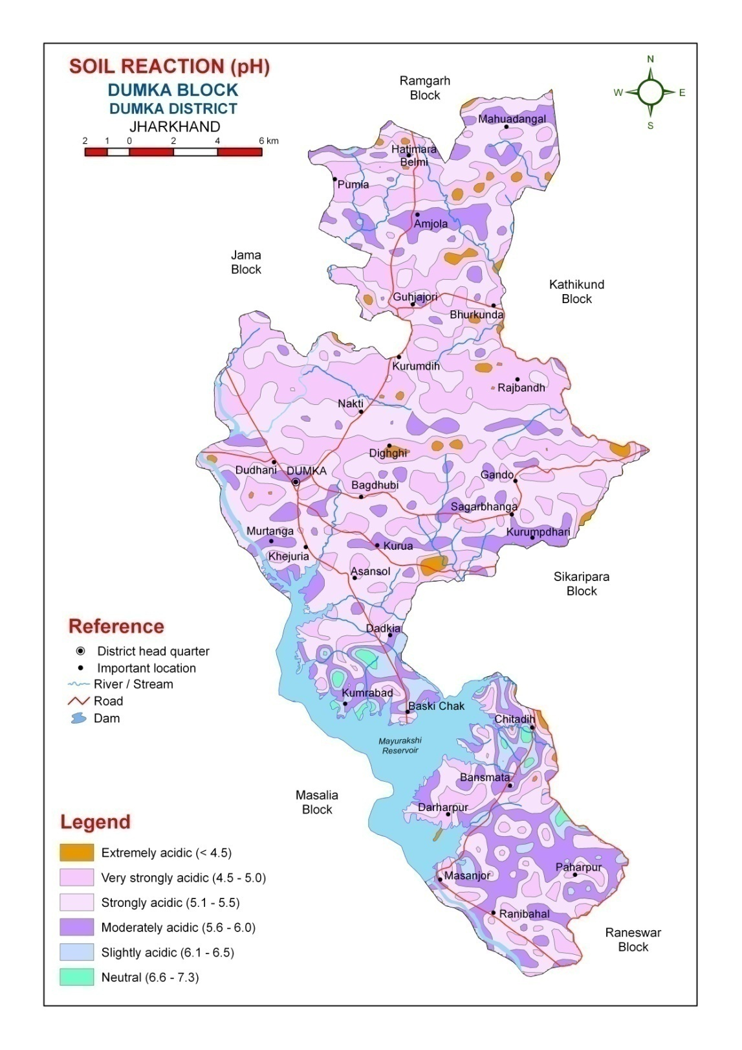
Fig. 2. Soil Reaction (pH) of Dumka Block of Dumka District, Jharkhand

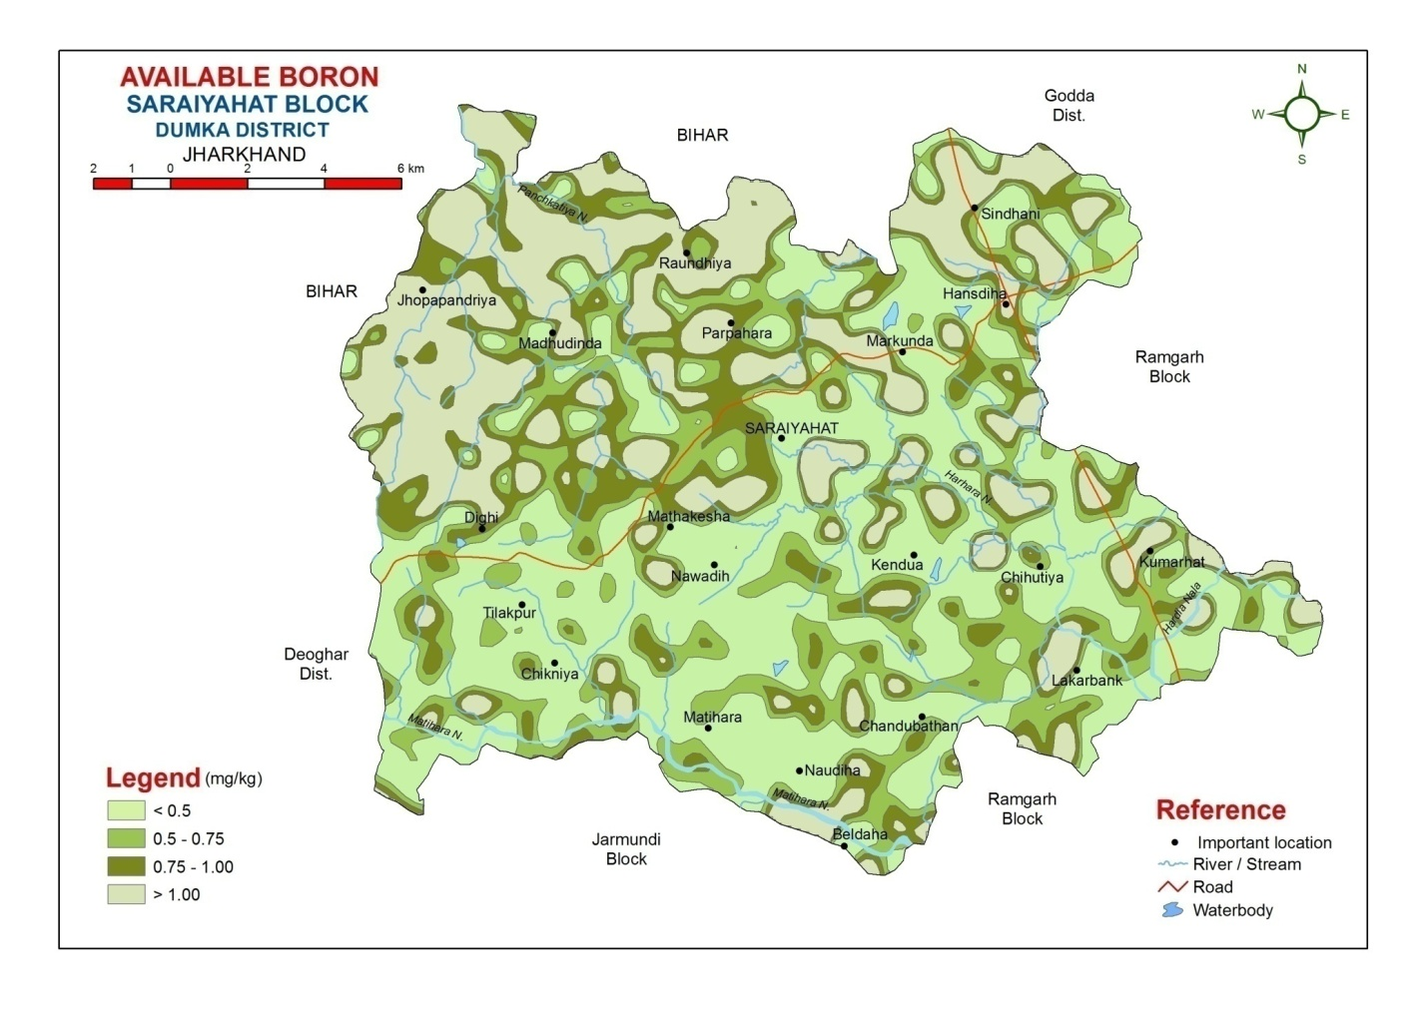
Fig. 3. Available Boron of Saraiyahat Block of Dumka District, Jharkhand

7.2 Supply chain management of soil amendments
Several materials have been identified as good soil ameliorant for acid soils. These are agricultural lime, dolomite, industrial wastes, such as basic slag, paper mill sludges, carbonated press mud from sugar industry etc. At present, there is no arrangement in place, for timely supply of soil amendments to farmers in different acid soil regions. Though the material is available, but its grinding, bagging, transport, marketing and quality control have not been arranged by state Governments. What is needed is that the state Governments ensure that lime/ dolomite/ paper mill sludge/ basic slag (choice based on local availability/ price/ quality etc.) is made available at block/ Panchayat level (preferably in small packing of 10-25 kg as per the average land holding in the area) .Close linkage with industry is necessary. Quality assurance is necessary before supply of the material (size, Calcium content, neutralizing value etc.). For this, supply chain management under a public-private partnership may be necessary for processing, transport and distribution of soil amendment in a timely and phased manner every year.

7.3 Soil test based Lime and Nutrient use
Soil testing facilities in most of the laboratories are in adequate. In spite of liberal funding by state and central Government projects, there exists an acute shortage of manpower and equipments in good working condition. This has resulted in poor transfer of data from STLs to farmers. This issue needs to be debated and addressed with all seriousness.
In acid soil regions, lime dose is fixed based on the lime requirement of soils. It is necessary that STLs have a ready reckoner for deciding the dose of lime for crops, based on pH, organic carbon and soil texture of major soil groups in a state. Further, periodic monitoring (every 3 years) of soil test values must be done to make adjustments in doses of lime and available plant nutrients, especially those ,which are often deficient. Linking of soil health cards with lime and nutrient application recommendations will bring about perceptible changes in the crop performance in acid soil areas.

7.4 Promotion of Resource conservation technologies
In most parts of north-east and eastern India, cultivation in hilly terrains with high rainfall, has resulted in massive land degradation, soil erosion, loss of soil organic matter and leaching of bases and plant nutrients. There is an emerging need to create awareness to check the loss of water, top soil, nutrients and organic matter to re-build the soil fertility. Conservation practices, such as growing of cover crops, mulching, residue incorporation, composting, minimum tillage etc. need to be promoted on a large scale to protect the natural resources. Water conservation and re-use in farm ponds, tanks, ditches especially in rain fed areas can help in mitigating the adverse effect of drought to some extent and help in protecting crop failure. Agroforestry has emerged as a viable option in the eastern hilly agro-ecosystem with large areas under acid soils. The hill slopes have problems of severe soil erosion, depletion of biodiversity, low crop productivity and crisis of both excess (rainy season) and abysmally low water availability (post-rainy season). The ICAR research Complex of NEH region has recommended that the lowest one-third of the slope be put to agricultural crops, where bench terracing be followed as the soil conservation measure. The mid one-third area is put to horti-pastoral system with conservation measures of half-moon terracing of horticultural plants. The top one-third portion of the slope should be put to agro-forestry with contour binding as the conservation measure (Prasad et al., 1981, 1997).

7.5 Empowering farmers with scientific technologies
Transfer of technologies has been seen as the outcome of research, extension and integration with farmer’s organizations. The role of each of these, extent of initiative and interaction among them and techniques of working have varied from time to time and place to place.
In order to accept and integrate into social systems, technologies must provide solutions to farmer’s problems and bring about positive changes. Development of technology is not enough. The policy, support services, feedback mechanisms, market linkages, training and orientation have to be ensured for success.
Indigenous technological knowledge of farmers (ITK) on soil fertility maintenance, soil and water conservation need to be actively considered while developing new technologies, since these are time tested, low cost, locally adapted and simple. In the technology transfer mechanisms, some of the areas, which need emphasis, are:
- Training of farmers and participation of farmers during technology development and its dissemination.
- Awareness creation through field functionaries, NGOs, farmers groups, KVK, ATMA, NGOs etc.
- Availability of a consolidated database on soils, water, inputs, crops, seeds, market at block/ Panchayat level.
- Ensuring supply of quality inputs at local level, such as lime, dolomite, fertilisers, seeds, plant protection measures.
- Hand holding at local level to promote dissemination of technology, keeping in view the farmer’s resources, investment capacity and level of management.
- The toll free helpline (1551) established at Kisan Call Centres, should be equipped to answer farmer’s problems.

Epilogue
Acidity is a major soil related constraints affecting agricultural productivity in about 18 M ha of land in India. These soils are spread in the Himalayan region, eastern and north-eastern plains, peninsular India and coastal plains under varying conditions of landscape, geology, climate and vegetation. Acid soils have low pH (less than 5.5), poor base saturation, high exchangeable aluminium concentration, and inadequate supply of several essential plant nutrients, such as N, P, Ca, Mg, B, Mo, S etc. Major growth limiting factors of these soils are the direct and indirect effects of metal toxicities, nutrient deficiencies, and poor soil biological activities.
During the last five decades, excellent research work has been carried out on the characterization of acid soils, their chemistry, genesis and classification, and management. The present paper is an attempt to review the good work on acid soil management. Results show that, besides the use of amendments, such as lime, dolomite, paper mill sludges, basic slag etc. there is need to look into the other complementary issues, which pose challenges for successful crop production and maintain soil health in the long run. Some such issues are managing the water availability in rain fed uplands and medium lands for increasing cropping intensity through inter-cropping/sequence cropping systems, agro-forestry, horticulture in hilly areas, promoting organic matter application and bio-fertilisers to boost soil biological activity, use of lime with plant nutrients deficient in acid soils with emphasis on secondary and micronutrients and checking soil degradation by different location specific measures. These measures along with soil amendments to raise the soil pH, have the potential to arrest the degradation process in acid soil regions.
Finally, a long term vision on soil acidity management has been provided. This comprises of work on a missionary mode on five priority areas: creation of a database of nutrients, amendments, irrigation, land holding etc at block, panchayat level, managing the supply and availability of soil amendments, linking soil health cards with use of amendments and nutrients in acid soil regions, promoting resource conservation technologies and addressing the transfer of technology concerns. The indicated measures need to be debated with the stakeholders and implemented for bringing about perceptible changes in the livelihood security of farmers and their families in regions affected by soil acidity in the next 5 to 10 years.

References
Anonymous.(2006) Consolidated Report of the ICAR Network Project on ‘Soil Characterization and Resource management of Acid soil regions for increasing productivity(2000-05),Nodal centre, B.A.U., Ranchi. pp.1-53.
Anonymous.(2016) Report of AICRP on Long Term Fertiliser Experiments, Ranchi Centre, B.A.U.,Ranchi.
Anonymous (2017) Report of AICRP on Micronutrients, East Zone, Indian Institute of Soil Science ,Bhopal.
Fan, S.(2013) Ensuring food and nutritional security in Asia: the role of Agricultural Innovation. 7th TAAS Foundation Day Lecture, I.A.R.I. New Delhi.
Jena, D.(2008) Management of acid soils for sustainable crop production. NAE-Acid soil Bulletin No.4, OUAT,Bhubaneshwar.
Jena,D.(2013a) Acid soils of Odisha. In ‘Acid soils-their Chemistry and Management’ (A.K.Sarkar,Ed.)pp. 197-256.New India Publishing Agency,New Delhi.
Maji,A.K.,Reddy,Obi,G.P.,and Sarkar,D.(2012). Acid soils of India-their extent and spatial variability.NBSS Publication,145,pp.1-138.NBSS & LUP,Nagpur.
Malavolta,E.(2006) Manual of mineral plant nutrition. Sao Paulo:Editora Agronomica ceres Ltda,pp. 1-631.
Mandal,S.C.,Sinha,H.,Prasad,C.R.,and Ali,M.A.(1966) Studies on liming acidic red loam soils. Journal of the Indian Society of Soil Science, 14: 127-131.
Mandal,S.C.,Sinha,M.K.,and Sinha,H.(1975) In Acid soils of India and Liming. ICAR Technical Bulletin no.75.
Mathur,B.S.,Rana,N.K.,Sinha,H.,and Lal,S.(1985) Lime as an effective source of fertiliser in acid red loam soil of Bihar. Journal of the Indian Society of Soil Science 33:328-332.
Mathur,B.S.,Rana,N.K.,Sinha,K.P.,and Lal,S.(1989) SSAC/BAU Research bulletin no.2/89,Birsa Agricultural University,Ranchi.
Murthy,R.S.,ShankaraNarayana,H.S.,and Hirekerur,L.R.(1976) Distribution,genesis and classification of acid soils of India. Bulletin of the Indian Society of Soil Science 11,1-17.
NAAS(2010) Degraded and Wastelands of India - Status and spatial distribution. National Academy of Agricultural Science, ICAR report. pp-1-155.
Panda,N.,Prasad,R.N.,Mukhopadhaya,A.K.,and Sarkar,A.K.(1991) Managing acid soils for optimum productivity in red ,laterite and associated soils of eastern India. Bulletin of the Indian Society of Soil Science,15:27-37.
Panda,N.,Sarkar,A.K.,and Mathur,B.S.(1996) Chemical degradation leading to soil acidity and its amelioration. Bulletin of the Indian Society of Soil Science.17:82-88.
Pattanayak,S.K.,Mohanty,S.,Mishra,K.N.,Nayak,R.K.,Mohanty,G.P.,and Rao,D.L.N.(2008) Technical Bulletin on ‘Biofertilisers for tropical vegetables’.All India Network Project on Biofertilsers,O.U.A.T.,Bhubaneshwar.
Pattanayak,S.K.,and Rao,D.L.N.(2014) Technical Bulletin on ‘Biofertilisers improve Tribal livelihood in Odisha’All India Network Project on Soil Biodiversity,biofertilisers(ICAR),O.U.A.T.,Bhubaneshwar.
Pattanayak,S.K., and Sarkar,A.K.(2016) Sustainable management of Acid soils-technologies and their transfer. Indian Journal of Fertilisers,12(7) pp.16-24&35.
Prasad,R.N.,Patiram,Barooah,R.C.,and Munna-Ram(1981) Soil and fertiliser management in N.E.Region. Bulletin 9,ICAR,Shillong.
Prasad,R.N.,Tewari,S.N.,and Munna-Ram(1997) Acid soils of north-east India and their management.In Acid soils of India (I.C.Mahapatra etal.,Eds.) .ICAR,New Delhi.pp.195-207.
Sahoo,A.K.,and Sarkar,D.(2013) Genesis and classification of acid soils of India. In Acid soils-their chemistry and management (A.K.Sarkar,Eds.).New India Publishing Agency,New Delhi.pp.49-104.
Sarkar,A.K.,and Singh,surendra(2003) Crop response to secondary and micronutrients in acidic soils of India. Fertilizer News.48(4):47-54.
Sarkar,A.K.,Mahapatra,P.,and Kumar,A.(2007) Management of Macronutrients in Acid soils. Bulletin of the Indian Society of Soil Science.25:10-26.
Sarkar,A.K.(2013) Soil health management in acid soils.In ‘soil health management’(HLS Tandon eds.)Fertiliser development and Consultative Organisation,New Delhi.pp.142-164.
Sharma,P.D. and Sarkar,A.K.(2006) Managing Acid soils for enhancing productivity.N.RM.Division(ICAR)KAB II,New Delhi.Technical bulletin 23:1-24.

___________________________________________________________________________

